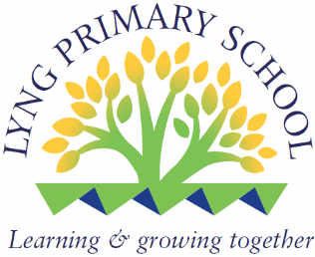

PERSONNEL SPECIFICATION
Job Title | Site Manager
Band/Job Group | Band D - ECS339
Hours/Weeks | 37 hours per week, 52 weeks per year
Special Conditions | Leave to be taken in school holidays
School | Lyng Primary School
Responsible to | Business Director

Sickness Absence and Disability | Candidates should have less than 4 absences in the last 6 months or not more than 10 days absence over the 12 months period prior to the closing date for the post. Any absences relating to a disability or any other incapacity will be viewed sympathetically and will be considered if fully explained. Due regard will be made to the need to make reasonable adjustments in line with the requirements of the Equality Act 2010. (This information will be obtained from successful candidate after conditional offer of employment has been made). Must be physically fit to undertake the duties.
Qualifications | Sound knowledge of Literacy and Numeracy.  Computer literate
Experience | At least 3 years experience in supervising and motivating staff.  Working with cleaning machinery and chemicals.  Monitoring staff.
Training | COSHH  IOSH  Manual Lifting  Asbestos  Fire Safety  Candidates should be willing to undertake this training if not already trained.
Special Knowledge | Knowledge of cleaning materials in connection with COSHH  Knowledge of fire safety  Knowledge of DIY rules and regulations
Circumstances | Flexible working patterns.  Ability to work evenings and weekends
Disposition | Dependable  To be able to work as part of a team and by oneself  Ability to motivate others
Practical and Intellectual Skills | Practical skills with regards to site improvements  To be able to use machinery  To be able to understand COSHH information
Legal Requirements | Enhanced DBS Check for Regulated Activity

